TASK 5

TOOL USED : MYSQL WORKBENCH

SQL QUERIES USING ALL JOINS TYPES

LEFT JOIN

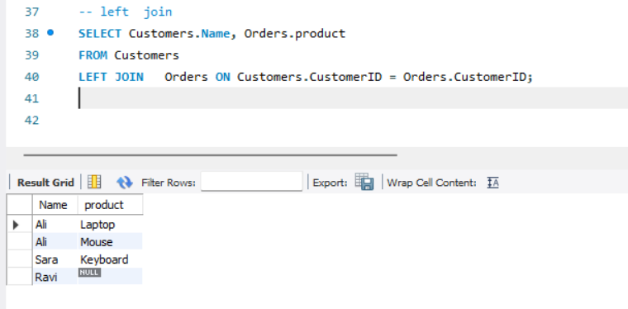

RIGHT JOIN

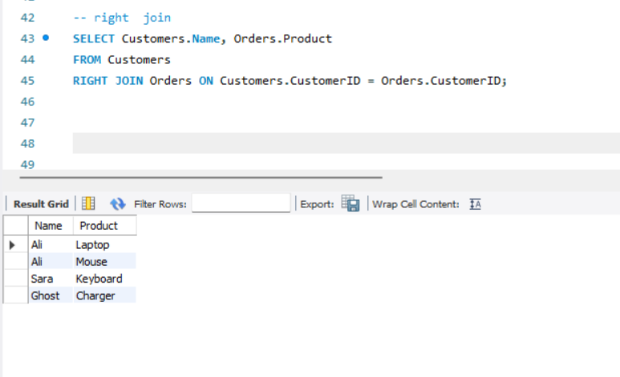

INNER JOIN

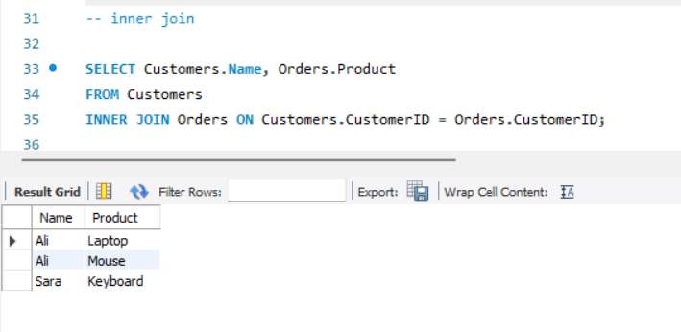

FULL OUTER JOIN

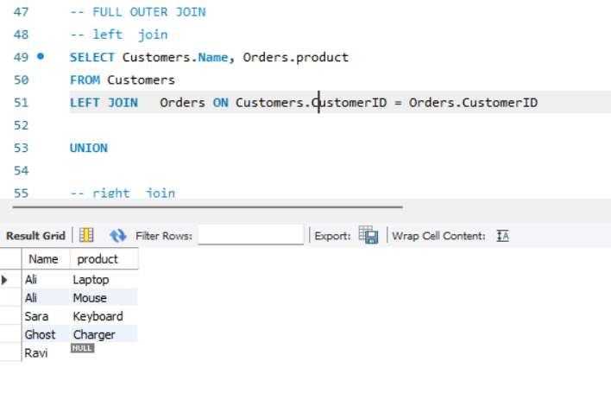

CROSS JOIN

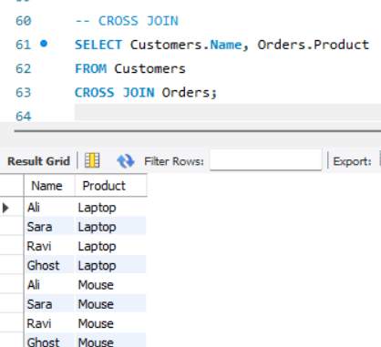

NATURAL JOIN

